# **Comprehensive Assessment :**

# **Deep Learning - Predicting Diabetes Progression using Artificial Neural Networks**

**Objective :**

The objective is to create a model that predicts how diabetes progresses using the given independent variables. This model will help healthcare professionals see how different factors affect diabetes progression, which can help them create better treatment plans and preventive strategies. The goal is to provide clear insights into how diabetes develops in patients over time.

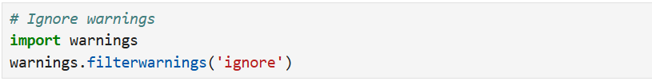

**Loading and Preprocessing**

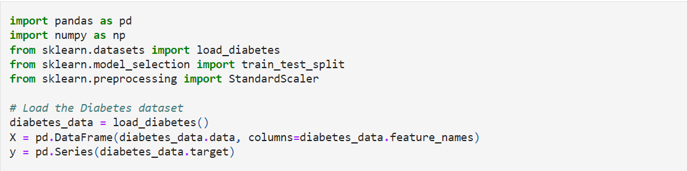



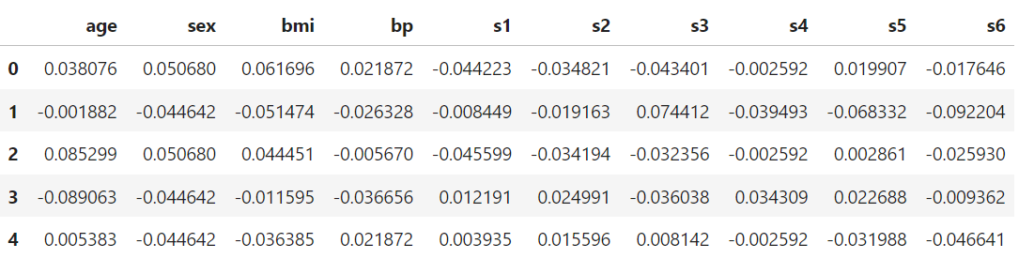



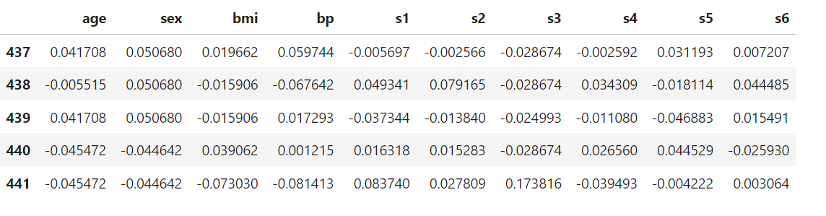

**Exploratory Data Analysis (EDA)**



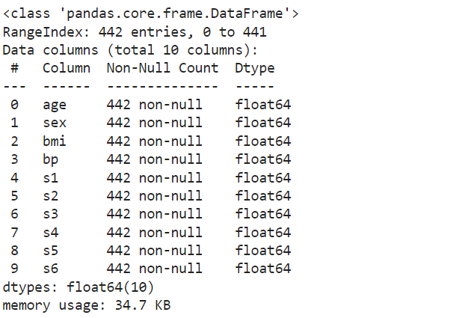

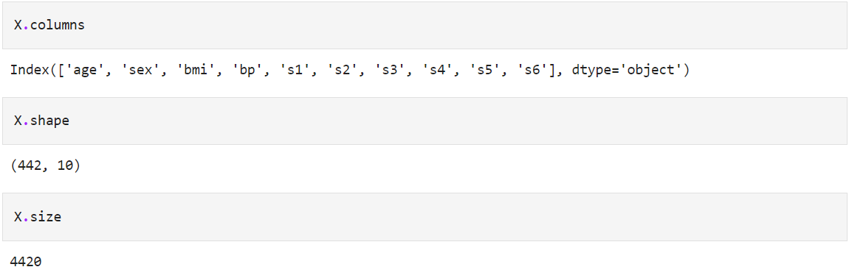

### 

### 

### 

### **Data Description**

This dataset is related to a diabetes study.This contains 442 samples with 10 normalized features and a target variable. The features include patient metrics like age, sex, Body Mass Index (BMI), blood pressure, and six blood serum measurements (s1-s6). The target variable represents a quantitative measure of diabetes progression one year after baseline. This data is typically used to model and predict how different factors influence the progression of diabetes, aiding in the understanding and management of the disease.

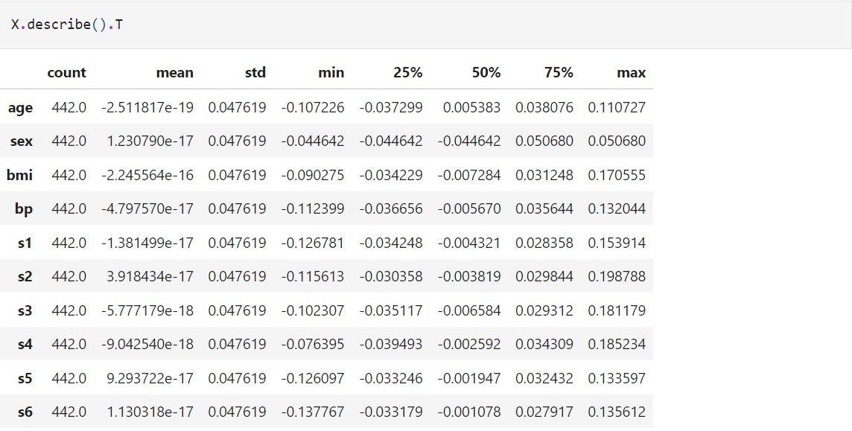

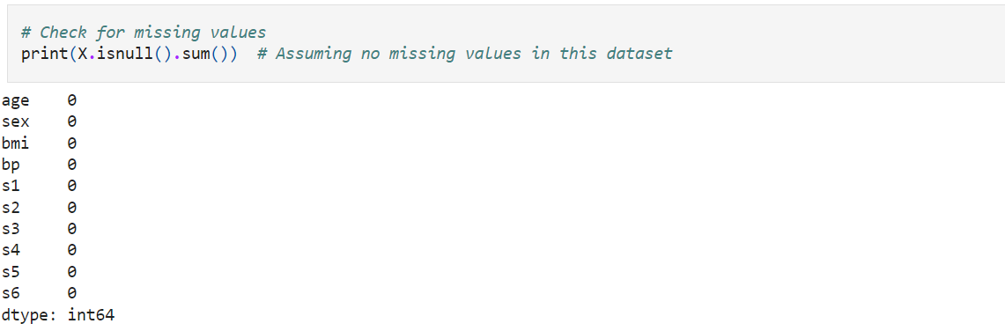

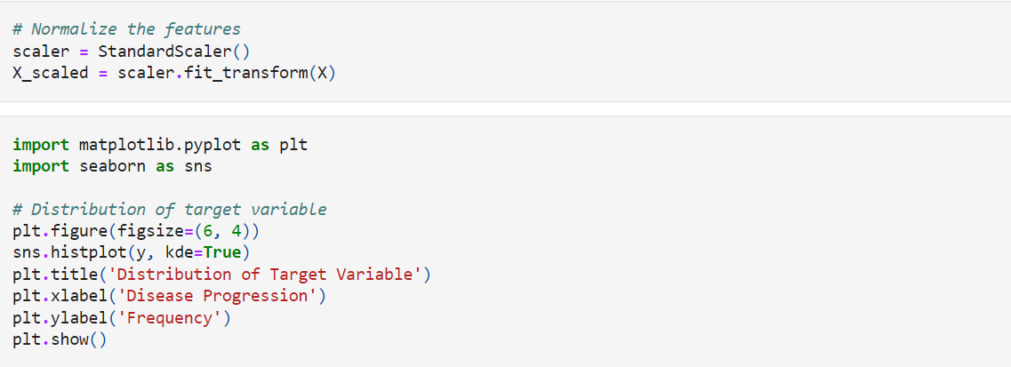

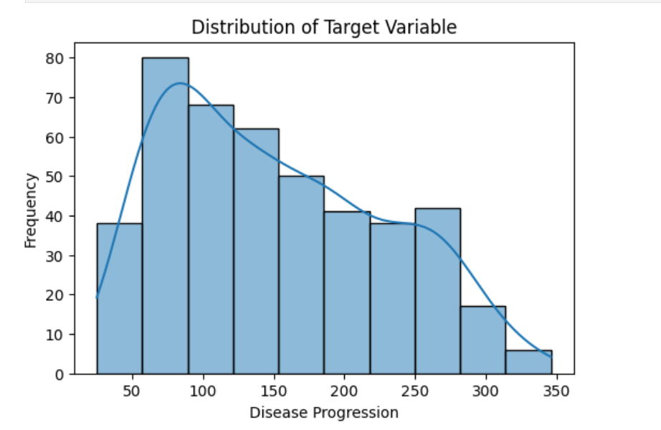

The histogram shows the distribution of the target variable related to disease progression. Here are some insights:

Right-Skewed Distribution: The data is concentrated on the left side, indicating that most patients have lower disease progression values. The frequency decreases as the disease progression value increases.

Frequency Peaks: The highest frequency of disease progression values is around the lower end of the scale, suggesting that a significant number of patients have mild disease progression.

Outliers: There are fewer instances of high disease progression, which could be outliers or rare cases.

Trend Line: The overlapping line graph, likely representing a probability distribution, follows the same right-skewed pattern, reinforcing the observation that lower disease progression values are more common.

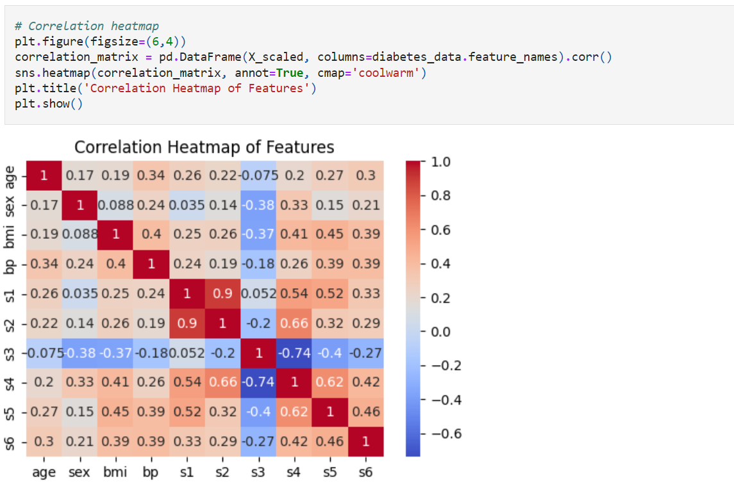

A correlation heatmap of various features. Here are some insights:

Strong Positive Correlations: s3 and s4: These features have a strong positive correlation, indicating that as one increases, the other tends to increase as well. bmi and bp: These features also show a strong positive correlation, suggesting a relationship between body mass index and blood pressure.

Strong Negative Correlations: bmi and s2: There’s a strong negative correlation here, meaning that as BMI increases, the value of s2 tends to decrease.

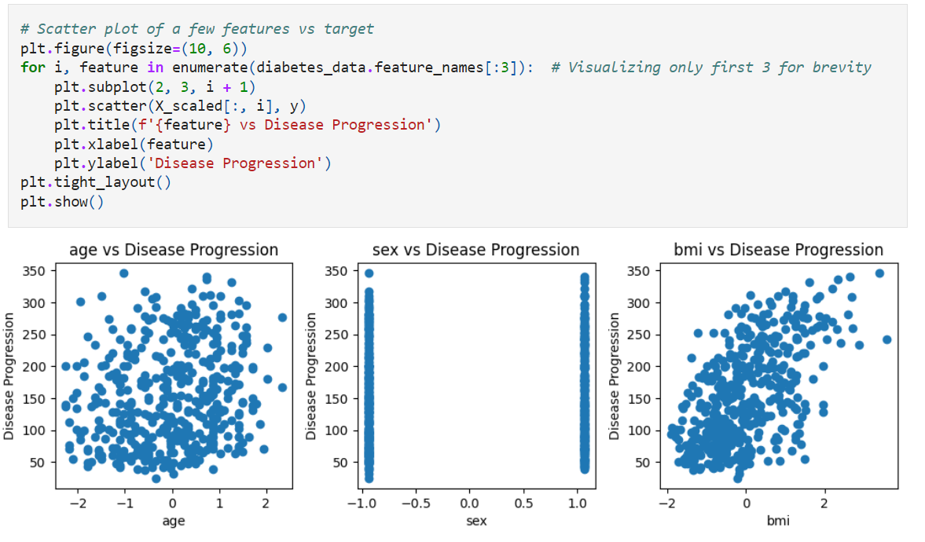

Age vs Disease Progression: There appears to be a slight positive correlation between age and disease progression, indicating that older individuals might experience higher disease progression.

Sex vs Disease Progression: The data points are spread out, suggesting no clear correlation between sex and disease progression. This implies that disease progression is relatively independent of sex.

BMI vs Disease Progression: There seems to be a moderate positive correlation between BMI and disease progression. Higher BMI values are associated with higher disease progression, indicating that body mass index could be a significant factor in disease progression.

**Building the ANN Model**

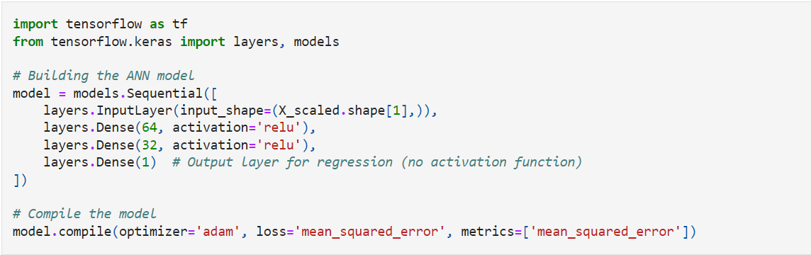

**Training the ANN Model**

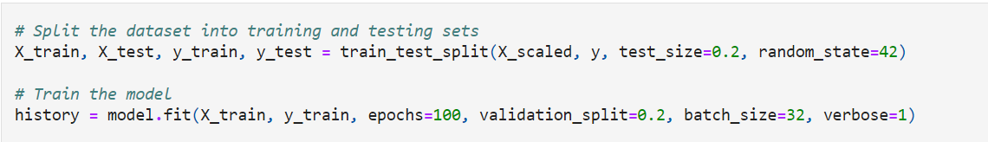

**Epoch 1/100**

**9/9 ━━━━━━━━━━━━━━━━━━━━ 0s 9ms/step - loss: 2082.4783 - mean_squared_error: 2082.4783 - val_loss: 3067.8521 - val_mean_squared_error: 3067.8521**

**Epoch 2/100**

**9/9 ━━━━━━━━━━━━━━━━━━━━ 0s 5ms/step - loss: 2152.0796 - mean_squared_error: 2152.0796 - val_loss: 3068.9246 - val_mean_squared_error: 3068.9246**

**Epoch 3/100**

**9/9 ━━━━━━━━━━━━━━━━━━━━ 0s 5ms/step - loss: 1933.4111 - mean_squared_error: 1933.4111 - val_loss: 3053.8147 - val_mean_squared_error: 3053.8147**

**Epoch 4/100**

**9/9 ━━━━━━━━━━━━━━━━━━━━ 0s 7ms/step - loss: 1737.1775 - mean_squared_error: 1737.1775 - val_loss: 3060.8293 - val_mean_squared_error: 3060.8293**

**Epoch 5/100**

**9/9 ━━━━━━━━━━━━━━━━━━━━ 0s 5ms/step - loss: 2010.4457 - mean_squared_error: 2010.4457 - val_loss: 3081.4590 - val_mean_squared_error: 3081.4590**

**Epoch 6/100**

**9/9 ━━━━━━━━━━━━━━━━━━━━ 0s 4ms/step - loss: 1948.1091 - mean_squared_error: 1948.1091 - val_loss: 3070.3164 - val_mean_squared_error: 3070.3164**

**Epoch 7/100**

**9/9 ━━━━━━━━━━━━━━━━━━━━ 0s 4ms/step - loss: 2291.7847 - mean_squared_error: 2291.7847 - val_loss: 3070.9277 - val_mean_squared_error: 3070.9277**

**Epoch 8/100**

**9/9 ━━━━━━━━━━━━━━━━━━━━ 0s 5ms/step - loss: 1852.9139 - mean_squared_error: 1852.9139 - val_loss: 3065.6013 - val_mean_squared_error: 3065.6013**

**Epoch 9/100**

**9/9 ━━━━━━━━━━━━━━━━━━━━ 0s 4ms/step - loss: 1920.2520 - mean_squared_error: 1920.2520 - val_loss: 3060.1997 - val_mean_squared_error: 3060.1997**

**Epoch 10/100**

**9/9 ━━━━━━━━━━━━━━━━━━━━ 0s 4ms/step - loss: 2010.2731 - mean_squared_error: 2010.2731 - val_loss: 3066.3176 - val_mean_squared_error: 3066.3176**

**Epoch 11/100**

**9/9 ━━━━━━━━━━━━━━━━━━━━ 0s 5ms/step - loss: 2008.3958 - mean_squared_error: 2008.3958 - val_loss: 3070.2466 - val_mean_squared_error: 3070.2466**

**Epoch 12/100**

**9/9 ━━━━━━━━━━━━━━━━━━━━ 0s 5ms/step - loss: 1967.7961 - mean_squared_error: 1967.7961 - val_loss: 3068.7456 - val_mean_squared_error: 3068.7456**

**Epoch 13/100**

**9/9 ━━━━━━━━━━━━━━━━━━━━ 0s 5ms/step - loss: 2157.9192 - mean_squared_error: 2157.9192 - val_loss: 3078.9185 - val_mean_squared_error: 3078.9185**

**Epoch 14/100**

**9/9 ━━━━━━━━━━━━━━━━━━━━ 0s 6ms/step - loss: 1983.6541 - mean_squared_error: 1983.6541 - val_loss: 3081.4241 - val_mean_squared_error: 3081.4241**

**Epoch 15/100**

**9/9 ━━━━━━━━━━━━━━━━━━━━ 0s 6ms/step - loss: 1746.7106 - mean_squared_error: 1746.7106 - val_loss: 3064.2236 - val_mean_squared_error: 3064.2236**

**Epoch 16/100**

**9/9 ━━━━━━━━━━━━━━━━━━━━ 0s 6ms/step - loss: 1893.5366 - mean_squared_error: 1893.5366 - val_loss: 3068.9050 - val_mean_squared_error: 3068.9050**

**Epoch 17/100**

**9/9 ━━━━━━━━━━━━━━━━━━━━ 0s 6ms/step - loss: 2075.0764 - mean_squared_error: 2075.0764 - val_loss: 3094.8247 - val_mean_squared_error: 3094.8247**

**Epoch 18/100**

**9/9 ━━━━━━━━━━━━━━━━━━━━ 0s 8ms/step - loss: 1883.2111 - mean_squared_error: 1883.2111 - val_loss: 3069.4387 - val_mean_squared_error: 3069.4387**

**Epoch 19/100**

**9/9 ━━━━━━━━━━━━━━━━━━━━ 0s 8ms/step - loss: 2125.0508 - mean_squared_error: 2125.0508 - val_loss: 3079.8181 - val_mean_squared_error: 3079.8181**

**Epoch 20/100**

**9/9 ━━━━━━━━━━━━━━━━━━━━ 0s 5ms/step - loss: 2029.1031 - mean_squared_error: 2029.1031 - val_loss: 3083.1436 - val_mean_squared_error: 3083.1436**

**Epoch 21/100**

**9/9 ━━━━━━━━━━━━━━━━━━━━ 0s 4ms/step - loss: 2146.7959 - mean_squared_error: 2146.7959 - val_loss: 3096.7314 - val_mean_squared_error: 3096.7314**

**Epoch 22/100**

**9/9 ━━━━━━━━━━━━━━━━━━━━ 0s 5ms/step - loss: 1823.1331 - mean_squared_error: 1823.1331 - val_loss: 3065.3862 - val_mean_squared_error: 3065.3862**

**Epoch 23/100**

**9/9 ━━━━━━━━━━━━━━━━━━━━ 0s 4ms/step - loss: 1929.8076 - mean_squared_error: 1929.8076 - val_loss: 3070.7556 - val_mean_squared_error: 3070.7556**

**Epoch 24/100**

**9/9 ━━━━━━━━━━━━━━━━━━━━ 0s 4ms/step - loss: 1984.4163 - mean_squared_error: 1984.4163 - val_loss: 3077.2668 - val_mean_squared_error: 3077.2668**

**Epoch 25/100**

**9/9 ━━━━━━━━━━━━━━━━━━━━ 0s 4ms/step - loss: 1869.4795 - mean_squared_error: 1869.4795 - val_loss: 3086.7527 - val_mean_squared_error: 3086.7527**

**Epoch 26/100**

**9/9 ━━━━━━━━━━━━━━━━━━━━ 0s 5ms/step - loss: 1911.4216 - mean_squared_error: 1911.4216 - val_loss: 3079.8955 - val_mean_squared_error: 3079.8955**

**Epoch 27/100**

**9/9 ━━━━━━━━━━━━━━━━━━━━ 0s 4ms/step - loss: 2063.4785 - mean_squared_error: 2063.4785 - val_loss: 3083.2805 - val_mean_squared_error: 3083.2805**

**Epoch 28/100**

**9/9 ━━━━━━━━━━━━━━━━━━━━ 0s 5ms/step - loss: 1863.4718 - mean_squared_error: 1863.4718 - val_loss: 3087.1365 - val_mean_squared_error: 3087.1365**

**Epoch 29/100**

**9/9 ━━━━━━━━━━━━━━━━━━━━ 0s 5ms/step - loss: 2059.5657 - mean_squared_error: 2059.5657 - val_loss: 3085.0154 - val_mean_squared_error: 3085.0154**

**Epoch 30/100**

**9/9 ━━━━━━━━━━━━━━━━━━━━ 0s 5ms/step - loss: 1947.1738 - mean_squared_error: 1947.1738 - val_loss: 3078.7185 - val_mean_squared_error: 3078.7185**

**Epoch 31/100**

**9/9 ━━━━━━━━━━━━━━━━━━━━ 0s 4ms/step - loss: 1944.4000 - mean_squared_error: 1944.4000 - val_loss: 3088.9165 - val_mean_squared_error: 3088.9165**

**Epoch 32/100**

**9/9 ━━━━━━━━━━━━━━━━━━━━ 0s 6ms/step - loss: 2032.0211 - mean_squared_error: 2032.0211 - val_loss: 3092.1360 - val_mean_squared_error: 3092.1360**

**Epoch 33/100**

**9/9 ━━━━━━━━━━━━━━━━━━━━ 0s 4ms/step - loss: 1775.3646 - mean_squared_error: 1775.3646 - val_loss: 3100.9624 - val_mean_squared_error: 3100.9624**

**Epoch 34/100**

**9/9 ━━━━━━━━━━━━━━━━━━━━ 0s 4ms/step - loss: 1942.2047 - mean_squared_error: 1942.2047 - val_loss: 3087.4688 - val_mean_squared_error: 3087.4688**

**Epoch 35/100**

**9/9 ━━━━━━━━━━━━━━━━━━━━ 0s 5ms/step - loss: 1895.0389 - mean_squared_error: 1895.0389 - val_loss: 3071.7620 - val_mean_squared_error: 3071.7620**

**Epoch 36/100**

**9/9 ━━━━━━━━━━━━━━━━━━━━ 0s 4ms/step - loss: 1913.7590 - mean_squared_error: 1913.7590 - val_loss: 3087.5557 - val_mean_squared_error: 3087.5557**

**Epoch 37/100**

**9/9 ━━━━━━━━━━━━━━━━━━━━ 0s 4ms/step - loss: 1944.8077 - mean_squared_error: 1944.8077 - val_loss: 3099.0728 - val_mean_squared_error: 3099.0728**

**Epoch 38/100**

**9/9 ━━━━━━━━━━━━━━━━━━━━ 0s 5ms/step - loss: 1740.2056 - mean_squared_error: 1740.2056 - val_loss: 3088.4680 - val_mean_squared_error: 3088.4680**

**Epoch 39/100**

**9/9 ━━━━━━━━━━━━━━━━━━━━ 0s 6ms/step - loss: 1886.0229 - mean_squared_error: 1886.0229 - val_loss: 3097.9019 - val_mean_squared_error: 3097.9019**

**Epoch 40/100**

**9/9 ━━━━━━━━━━━━━━━━━━━━ 0s 5ms/step - loss: 1915.1707 - mean_squared_error: 1915.1707 - val_loss: 3090.3696 - val_mean_squared_error: 3090.3696**

**Epoch 41/100**

**9/9 ━━━━━━━━━━━━━━━━━━━━ 0s 5ms/step - loss: 1768.9379 - mean_squared_error: 1768.9379 - val_loss: 3096.4053 - val_mean_squared_error: 3096.4053**

**Epoch 42/100**

**9/9 ━━━━━━━━━━━━━━━━━━━━ 0s 4ms/step - loss: 1885.4775 - mean_squared_error: 1885.4775 - val_loss: 3100.4631 - val_mean_squared_error: 3100.4631**

**Epoch 43/100**

**9/9 ━━━━━━━━━━━━━━━━━━━━ 0s 4ms/step - loss: 1814.2511 - mean_squared_error: 1814.2511 - val_loss: 3092.5190 - val_mean_squared_error: 3092.5190**

**Epoch 44/100**

**9/9 ━━━━━━━━━━━━━━━━━━━━ 0s 4ms/step - loss: 1846.7079 - mean_squared_error: 1846.7079 - val_loss: 3094.0557 - val_mean_squared_error: 3094.0557**

**Epoch 45/100**

**9/9 ━━━━━━━━━━━━━━━━━━━━ 0s 7ms/step - loss: 2011.9336 - mean_squared_error: 2011.9336 - val_loss: 3100.6558 - val_mean_squared_error: 3100.6558**

**Epoch 46/100**

**9/9 ━━━━━━━━━━━━━━━━━━━━ 0s 4ms/step - loss: 1891.0687 - mean_squared_error: 1891.0687 - val_loss: 3093.1157 - val_mean_squared_error: 3093.1157**

**Epoch 47/100**

**9/9 ━━━━━━━━━━━━━━━━━━━━ 0s 5ms/step - loss: 2083.0815 - mean_squared_error: 2083.0815 - val_loss: 3102.2935 - val_mean_squared_error: 3102.2935**

**Epoch 48/100**

**9/9 ━━━━━━━━━━━━━━━━━━━━ 0s 4ms/step - loss: 1777.5596 - mean_squared_error: 1777.5596 - val_loss: 3108.2034 - val_mean_squared_error: 3108.2034**

**Epoch 49/100**

**9/9 ━━━━━━━━━━━━━━━━━━━━ 0s 6ms/step - loss: 2078.5967 - mean_squared_error: 2078.5967 - val_loss: 3098.8694 - val_mean_squared_error: 3098.8694**

**Epoch 50/100**

**9/9 ━━━━━━━━━━━━━━━━━━━━ 0s 5ms/step - loss: 2049.0156 - mean_squared_error: 2049.0156 - val_loss: 3092.8096 - val_mean_squared_error: 3092.8096**

**Epoch 51/100**

**9/9 ━━━━━━━━━━━━━━━━━━━━ 0s 4ms/step - loss: 2030.9128 - mean_squared_error: 2030.9128 - val_loss: 3099.2419 - val_mean_squared_error: 3099.2419**

**Epoch 52/100**

**9/9 ━━━━━━━━━━━━━━━━━━━━ 0s 5ms/step - loss: 1799.9976 - mean_squared_error: 1799.9976 - val_loss: 3110.2131 - val_mean_squared_error: 3110.2131**

**Epoch 53/100**

**9/9 ━━━━━━━━━━━━━━━━━━━━ 0s 6ms/step - loss: 1680.1602 - mean_squared_error: 1680.1602 - val_loss: 3119.4319 - val_mean_squared_error: 3119.4319**

**Epoch 54/100**

**9/9 ━━━━━━━━━━━━━━━━━━━━ 0s 4ms/step - loss: 1826.3684 - mean_squared_error: 1826.3684 - val_loss: 3097.3970 - val_mean_squared_error: 3097.3972**

**Epoch 55/100**

**9/9 ━━━━━━━━━━━━━━━━━━━━ 0s 6ms/step - loss: 1736.7139 - mean_squared_error: 1736.7139 - val_loss: 3098.7183 - val_mean_squared_error: 3098.7183**

**Epoch 56/100**

**9/9 ━━━━━━━━━━━━━━━━━━━━ 0s 5ms/step - loss: 1942.2594 - mean_squared_error: 1942.2594 - val_loss: 3114.0898 - val_mean_squared_error: 3114.0898**

**Epoch 57/100**

**9/9 ━━━━━━━━━━━━━━━━━━━━ 0s 4ms/step - loss: 1596.3528 - mean_squared_error: 1596.3528 - val_loss: 3118.5222 - val_mean_squared_error: 3118.5222**

**Epoch 58/100**

**9/9 ━━━━━━━━━━━━━━━━━━━━ 0s 4ms/step - loss: 2106.8293 - mean_squared_error: 2106.8293 - val_loss: 3113.9780 - val_mean_squared_error: 3113.9780**

**Epoch 59/100**

**9/9 ━━━━━━━━━━━━━━━━━━━━ 0s 3ms/step - loss: 1980.2277 - mean_squared_error: 1980.2277 - val_loss: 3115.6670 - val_mean_squared_error: 3115.6670**

**Epoch 60/100**

**9/9 ━━━━━━━━━━━━━━━━━━━━ 0s 5ms/step - loss: 2033.3899 - mean_squared_error: 2033.3899 - val_loss: 3123.2458 - val_mean_squared_error: 3123.2458**

**Epoch 61/100**

**9/9 ━━━━━━━━━━━━━━━━━━━━ 0s 4ms/step - loss: 1788.9854 - mean_squared_error: 1788.9854 - val_loss: 3108.0210 - val_mean_squared_error: 3108.0210**

**Epoch 62/100**

**9/9 ━━━━━━━━━━━━━━━━━━━━ 0s 7ms/step - loss: 1862.7495 - mean_squared_error: 1862.7495 - val_loss: 3104.5457 - val_mean_squared_error: 3104.5457**

**Epoch 63/100**

**9/9 ━━━━━━━━━━━━━━━━━━━━ 0s 6ms/step - loss: 2022.1453 - mean_squared_error: 2022.1453 - val_loss: 3124.2688 - val_mean_squared_error: 3124.2688**

**Epoch 64/100**

**9/9 ━━━━━━━━━━━━━━━━━━━━ 0s 6ms/step - loss: 1954.2552 - mean_squared_error: 1954.2552 - val_loss: 3127.0132 - val_mean_squared_error: 3127.0132**

**Epoch 65/100**

**9/9 ━━━━━━━━━━━━━━━━━━━━ 0s 4ms/step - loss: 2032.0189 - mean_squared_error: 2032.0189 - val_loss: 3116.6516 - val_mean_squared_error: 3116.6516**

**Epoch 66/100**

**9/9 ━━━━━━━━━━━━━━━━━━━━ 0s 4ms/step - loss: 1789.1638 - mean_squared_error: 1789.1638 - val_loss: 3117.8071 - val_mean_squared_error: 3117.8071**

**Epoch 67/100**

**9/9 ━━━━━━━━━━━━━━━━━━━━ 0s 6ms/step - loss: 1884.9382 - mean_squared_error: 1884.9382 - val_loss: 3130.6853 - val_mean_squared_error: 3130.6853**

**Epoch 68/100**

**9/9 ━━━━━━━━━━━━━━━━━━━━ 0s 5ms/step - loss: 1794.7305 - mean_squared_error: 1794.7305 - val_loss: 3121.7083 - val_mean_squared_error: 3121.7083**

**Epoch 69/100**

**9/9 ━━━━━━━━━━━━━━━━━━━━ 0s 5ms/step - loss: 1887.4711 - mean_squared_error: 1887.4711 - val_loss: 3120.1470 - val_mean_squared_error: 3120.1470**

**Epoch 70/100**

**9/9 ━━━━━━━━━━━━━━━━━━━━ 0s 4ms/step - loss: 1814.4734 - mean_squared_error: 1814.4734 - val_loss: 3146.0608 - val_mean_squared_error: 3146.0608**

**Epoch 71/100**

**9/9 ━━━━━━━━━━━━━━━━━━━━ 0s 5ms/step - loss: 2185.0151 - mean_squared_error: 2185.0151 - val_loss: 3133.6985 - val_mean_squared_error: 3133.6985**

**Epoch 72/100**

**9/9 ━━━━━━━━━━━━━━━━━━━━ 0s 4ms/step - loss: 1635.5820 - mean_squared_error: 1635.5820 - val_loss: 3116.9775 - val_mean_squared_error: 3116.9775**

**Epoch 73/100**

**9/9 ━━━━━━━━━━━━━━━━━━━━ 0s 4ms/step - loss: 1862.7325 - mean_squared_error: 1862.7325 - val_loss: 3128.7715 - val_mean_squared_error: 3128.7715**

**Epoch 74/100**

**9/9 ━━━━━━━━━━━━━━━━━━━━ 0s 5ms/step - loss: 1773.3237 - mean_squared_error: 1773.3237 - val_loss: 3135.9094 - val_mean_squared_error: 3135.9094**

**Epoch 75/100**

**9/9 ━━━━━━━━━━━━━━━━━━━━ 0s 4ms/step - loss: 1984.4238 - mean_squared_error: 1984.4238 - val_loss: 3121.8010 - val_mean_squared_error: 3121.8010**

**Epoch 76/100**

**9/9 ━━━━━━━━━━━━━━━━━━━━ 0s 5ms/step - loss: 1682.3236 - mean_squared_error: 1682.3236 - val_loss: 3130.5225 - val_mean_squared_error: 3130.5225**

**Epoch 77/100**

**9/9 ━━━━━━━━━━━━━━━━━━━━ 0s 4ms/step - loss: 1783.7981 - mean_squared_error: 1783.7981 - val_loss: 3145.3945 - val_mean_squared_error: 3145.3945**

**Epoch 78/100**

**9/9 ━━━━━━━━━━━━━━━━━━━━ 0s 4ms/step - loss: 1649.5383 - mean_squared_error: 1649.5383 - val_loss: 3143.9941 - val_mean_squared_error: 3143.9941**

**Epoch 79/100**

**9/9 ━━━━━━━━━━━━━━━━━━━━ 0s 4ms/step - loss: 1753.5540 - mean_squared_error: 1753.5540 - val_loss: 3130.4656 - val_mean_squared_error: 3130.4656**

**Epoch 80/100**

**9/9 ━━━━━━━━━━━━━━━━━━━━ 0s 6ms/step - loss: 1781.9315 - mean_squared_error: 1781.9315 - val_loss: 3131.6328 - val_mean_squared_error: 3131.6328**

**Epoch 81/100**

**9/9 ━━━━━━━━━━━━━━━━━━━━ 0s 5ms/step - loss: 1736.9485 - mean_squared_error: 1736.9485 - val_loss: 3144.4856 - val_mean_squared_error: 3144.4856**

**Epoch 82/100**

**9/9 ━━━━━━━━━━━━━━━━━━━━ 0s 5ms/step - loss: 1777.9380 - mean_squared_error: 1777.9380 - val_loss: 3143.2803 - val_mean_squared_error: 3143.2803**

**Epoch 83/100**

**9/9 ━━━━━━━━━━━━━━━━━━━━ 0s 4ms/step - loss: 1787.9856 - mean_squared_error: 1787.9856 - val_loss: 3156.1465 - val_mean_squared_error: 3156.1465**

**Epoch 84/100**

**9/9 ━━━━━━━━━━━━━━━━━━━━ 0s 4ms/step - loss: 1951.1559 - mean_squared_error: 1951.1559 - val_loss: 3139.0913 - val_mean_squared_error: 3139.0913**

**Epoch 85/100**

**9/9 ━━━━━━━━━━━━━━━━━━━━ 0s 5ms/step - loss: 1586.2915 - mean_squared_error: 1586.2915 - val_loss: 3141.5737 - val_mean_squared_error: 3141.5737**

**Epoch 86/100**

**9/9 ━━━━━━━━━━━━━━━━━━━━ 0s 5ms/step - loss: 1739.0564 - mean_squared_error: 1739.0564 - val_loss: 3138.8801 - val_mean_squared_error: 3138.8801**

**Epoch 87/100**

**9/9 ━━━━━━━━━━━━━━━━━━━━ 0s 5ms/step - loss: 1669.0669 - mean_squared_error: 1669.0669 - val_loss: 3148.9661 - val_mean_squared_error: 3148.9661**

**Epoch 88/100**

**9/9 ━━━━━━━━━━━━━━━━━━━━ 0s 5ms/step - loss: 1907.8059 - mean_squared_error: 1907.8059 - val_loss: 3143.1655 - val_mean_squared_error: 3143.1655**

**Epoch 89/100**

**9/9 ━━━━━━━━━━━━━━━━━━━━ 0s 5ms/step - loss: 1693.9878 - mean_squared_error: 1693.9878 - val_loss: 3143.4634 - val_mean_squared_error: 3143.4634**

**Epoch 90/100**

**9/9 ━━━━━━━━━━━━━━━━━━━━ 0s 7ms/step - loss: 1611.9756 - mean_squared_error: 1611.9756 - val_loss: 3152.4080 - val_mean_squared_error: 3152.4080**

**Epoch 91/100**

**9/9 ━━━━━━━━━━━━━━━━━━━━ 0s 7ms/step - loss: 1743.1879 - mean_squared_error: 1743.1879 - val_loss: 3161.2466 - val_mean_squared_error: 3161.2466**

**Epoch 92/100**

**9/9 ━━━━━━━━━━━━━━━━━━━━ 0s 6ms/step - loss: 1864.3102 - mean_squared_error: 1864.3102 - val_loss: 3167.8833 - val_mean_squared_error: 3167.8833**

**Epoch 93/100**

**9/9 ━━━━━━━━━━━━━━━━━━━━ 0s 4ms/step - loss: 1697.6698 - mean_squared_error: 1697.6698 - val_loss: 3159.4756 - val_mean_squared_error: 3159.4756**

**Epoch 94/100**

**9/9 ━━━━━━━━━━━━━━━━━━━━ 0s 5ms/step - loss: 1948.2258 - mean_squared_error: 1948.2258 - val_loss: 3150.7944 - val_mean_squared_error: 3150.7944**

**Epoch 95/100**

**9/9 ━━━━━━━━━━━━━━━━━━━━ 0s 5ms/step - loss: 1974.1299 - mean_squared_error: 1974.1299 - val_loss: 3149.4490 - val_mean_squared_error: 3149.4490**

**Epoch 96/100**

**9/9 ━━━━━━━━━━━━━━━━━━━━ 0s 5ms/step - loss: 1785.5802 - mean_squared_error: 1785.5802 - val_loss: 3161.1013 - val_mean_squared_error: 3161.1013**

**Epoch 97/100**

**9/9 ━━━━━━━━━━━━━━━━━━━━ 0s 5ms/step - loss: 1733.0936 - mean_squared_error: 1733.0936 - val_loss: 3174.3789 - val_mean_squared_error: 3174.3789**

**Epoch 98/100**

**9/9 ━━━━━━━━━━━━━━━━━━━━ 0s 4ms/step - loss: 1912.0836 - mean_squared_error: 1912.0836 - val_loss: 3161.1677 - val_mean_squared_error: 3161.1677**

**Epoch 99/100**

**9/9 ━━━━━━━━━━━━━━━━━━━━ 0s 4ms/step - loss: 1945.0046 - mean_squared_error: 1945.0046 - val_loss: 3166.8491 - val_mean_squared_error: 3166.8491**

**Epoch 100/100**

**9/9 ━━━━━━━━━━━━━━━━━━━━ 0s 6ms/step - loss: 1745.3781 - mean_squared_error: 1745.3781 - val_loss: 3169.8652 - val_mean_squared_error: 3169.8652**

**Evaluating the Model**

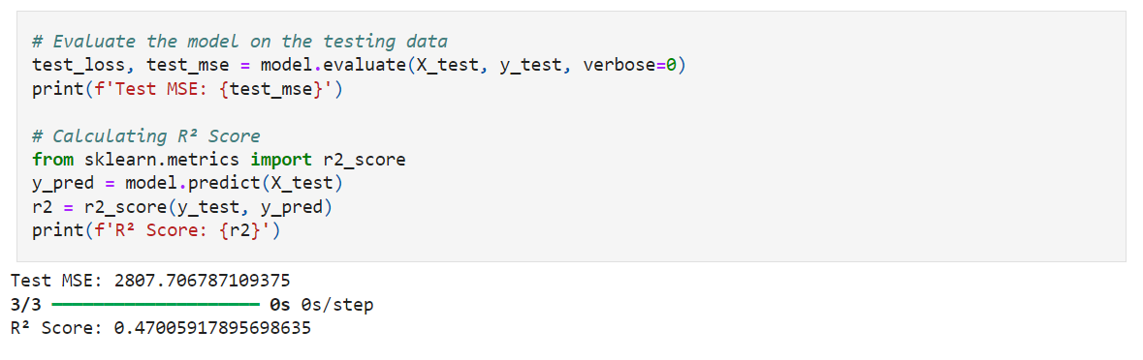

**Improving the Model**

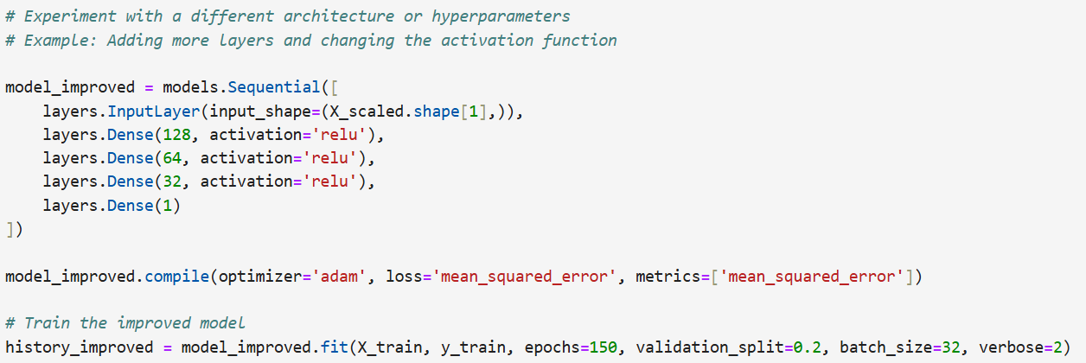

**Epoch 1/150**

**9/9 - 1s - 148ms/step - loss: 31470.2695 - mean_squared_error: 31470.2695 - val_loss: 22338.1035 - val_mean_squared_error: 22338.1035**

**Epoch 2/150**

**9/9 - 0s - 6ms/step - loss: 31203.8184 - mean_squared_error: 31203.8184 - val_loss: 22084.1621 - val_mean_squared_error: 22084.1621**

**Epoch 3/150**

**9/9 - 0s - 8ms/step - loss: 30755.0430 - mean_squared_error: 30755.0430 - val_loss: 21585.0098 - val_mean_squared_error: 21585.0098**

**Epoch 4/150**

**9/9 - 0s - 8ms/step - loss: 29862.1426 - mean_squared_error: 29862.1426 - val_loss: 20610.1621 - val_mean_squared_error: 20610.1621**

**Epoch 5/150**

**9/9 - 0s - 8ms/step - loss: 28128.3223 - mean_squared_error: 28128.3223 - val_loss: 18855.3848 - val_mean_squared_error: 18855.3848**

**Epoch 6/150**

**9/9 - 0s - 8ms/step - loss: 25114.1562 - mean_squared_error: 25114.1562 - val_loss: 16014.0137 - val_mean_squared_error: 16014.0137**

**Epoch 7/150**

**9/9 - 0s - 8ms/step - loss: 20412.2148 - mean_squared_error: 20412.2148 - val_loss: 12055.4150 - val_mean_squared_error: 12055.4150**

**Epoch 8/150**

**9/9 - 0s - 10ms/step - loss: 14607.5693 - mean_squared_error: 14607.5693 - val_loss: 7620.1274 - val_mean_squared_error: 7620.1274**

**Epoch 9/150**

**9/9 - 0s - 7ms/step - loss: 8722.0303 - mean_squared_error: 8722.0303 - val_loss: 4530.1167 - val_mean_squared_error: 4530.1167**

**Epoch 10/150**

**9/9 - 0s - 9ms/step - loss: 6454.6543 - mean_squared_error: 6454.6543 - val_loss: 3651.6423 - val_mean_squared_error: 3651.6423**

**Epoch 11/150**

**9/9 - 0s - 9ms/step - loss: 5741.2812 - mean_squared_error: 5741.2812 - val_loss: 3443.3682 - val_mean_squared_error: 3443.3682**

**Epoch 12/150**

**9/9 - 0s - 9ms/step - loss: 4964.2744 - mean_squared_error: 4964.2744 - val_loss: 3341.1255 - val_mean_squared_error: 3341.1255**

**Epoch 13/150**

**9/9 - 0s - 7ms/step - loss: 4468.8726 - mean_squared_error: 4468.8726 - val_loss: 3289.7981 - val_mean_squared_error: 3289.7981**

**Epoch 14/150**

**9/9 - 0s - 8ms/step - loss: 4200.8643 - mean_squared_error: 4200.8643 - val_loss: 3198.9363 - val_mean_squared_error: 3198.9363**

**Epoch 15/150**

**9/9 - 0s - 7ms/step - loss: 3962.2847 - mean_squared_error: 3962.2847 - val_loss: 3120.3738 - val_mean_squared_error: 3120.3738**

**Epoch 16/150**

**9/9 - 0s - 8ms/step - loss: 3814.6511 - mean_squared_error: 3814.6511 - val_loss: 3035.5569 - val_mean_squared_error: 3035.5569**

**Epoch 17/150**

**9/9 - 0s - 7ms/step - loss: 3686.9539 - mean_squared_error: 3686.9539 - val_loss: 3004.8970 - val_mean_squared_error: 3004.8970**

**Epoch 18/150**

**9/9 - 0s - 9ms/step - loss: 3568.9001 - mean_squared_error: 3568.9001 - val_loss: 2971.6934 - val_mean_squared_error: 2971.6934**

**Epoch 19/150**

**9/9 - 0s - 12ms/step - loss: 3469.0579 - mean_squared_error: 3469.0579 - val_loss: 2941.6858 - val_mean_squared_error: 2941.6858**

**Epoch 20/150**

**9/9 - 0s - 9ms/step - loss: 3390.6956 - mean_squared_error: 3390.6956 - val_loss: 2916.0122 - val_mean_squared_error: 2916.0122**

**Epoch 21/150**

**9/9 - 0s - 7ms/step - loss: 3330.4583 - mean_squared_error: 3330.4583 - val_loss: 2890.3511 - val_mean_squared_error: 2890.3511**

**Epoch 22/150**

**9/9 - 0s - 7ms/step - loss: 3270.7747 - mean_squared_error: 3270.7747 - val_loss: 2873.5452 - val_mean_squared_error: 2873.5452**

**Epoch 23/150**

**9/9 - 0s - 9ms/step - loss: 3204.4626 - mean_squared_error: 3204.4626 - val_loss: 2849.4211 - val_mean_squared_error: 2849.4211**

**Epoch 24/150**

**9/9 - 0s - 8ms/step - loss: 3164.0527 - mean_squared_error: 3164.0527 - val_loss: 2843.7800 - val_mean_squared_error: 2843.7800**

**Epoch 25/150**

**9/9 - 0s - 11ms/step - loss: 3122.5439 - mean_squared_error: 3122.5439 - val_loss: 2828.0779 - val_mean_squared_error: 2828.0779**

**Epoch 26/150**

**9/9 - 0s - 10ms/step - loss: 3084.3489 - mean_squared_error: 3084.3489 - val_loss: 2814.8665 - val_mean_squared_error: 2814.8665**

**Epoch 27/150**

**9/9 - 0s - 8ms/step - loss: 3051.0571 - mean_squared_error: 3051.0571 - val_loss: 2802.9021 - val_mean_squared_error: 2802.9021**

**Epoch 28/150**

**9/9 - 0s - 8ms/step - loss: 3037.1921 - mean_squared_error: 3037.1921 - val_loss: 2812.8315 - val_mean_squared_error: 2812.8315**

**Epoch 29/150**

**9/9 - 0s - 16ms/step - loss: 2999.3901 - mean_squared_error: 2999.3901 - val_loss: 2790.2922 - val_mean_squared_error: 2790.2922**

**Epoch 30/150**

**9/9 - 0s - 11ms/step - loss: 2971.3235 - mean_squared_error: 2971.3235 - val_loss: 2781.0471 - val_mean_squared_error: 2781.0471**

**Epoch 31/150**

**9/9 - 0s - 8ms/step - loss: 2951.2354 - mean_squared_error: 2951.2354 - val_loss: 2792.7275 - val_mean_squared_error: 2792.7275**

**Epoch 32/150**

**9/9 - 0s - 9ms/step - loss: 2926.6841 - mean_squared_error: 2926.6841 - val_loss: 2768.8728 - val_mean_squared_error: 2768.8728**

**Epoch 33/150**

**9/9 - 0s - 7ms/step - loss: 2904.7170 - mean_squared_error: 2904.7170 - val_loss: 2773.5911 - val_mean_squared_error: 2773.5911**

**Epoch 34/150**

**9/9 - 0s - 9ms/step - loss: 2891.8721 - mean_squared_error: 2891.8721 - val_loss: 2779.5808 - val_mean_squared_error: 2779.5808**

**Epoch 35/150**

**9/9 - 0s - 13ms/step - loss: 2887.4109 - mean_squared_error: 2887.4109 - val_loss: 2768.1572 - val_mean_squared_error: 2768.1572**

**Epoch 36/150**

**9/9 - 0s - 10ms/step - loss: 2855.4258 - mean_squared_error: 2855.4258 - val_loss: 2769.2207 - val_mean_squared_error: 2769.2207**

**Epoch 37/150**

**9/9 - 0s - 10ms/step - loss: 2837.5554 - mean_squared_error: 2837.5554 - val_loss: 2771.4539 - val_mean_squared_error: 2771.4539**

**Epoch 38/150**

**9/9 - 0s - 8ms/step - loss: 2813.5261 - mean_squared_error: 2813.5261 - val_loss: 2785.4922 - val_mean_squared_error: 2785.4922**

**Epoch 39/150**

**9/9 - 0s - 8ms/step - loss: 2806.1453 - mean_squared_error: 2806.1453 - val_loss: 2783.0571 - val_mean_squared_error: 2783.0571**

**Epoch 40/150**

**9/9 - 0s - 8ms/step - loss: 2790.0586 - mean_squared_error: 2790.0586 - val_loss: 2767.5237 - val_mean_squared_error: 2767.5237**

**Epoch 41/150**

**9/9 - 0s - 8ms/step - loss: 2780.5132 - mean_squared_error: 2780.5132 - val_loss: 2767.4719 - val_mean_squared_error: 2767.4719**

**Epoch 42/150**

**9/9 - 0s - 8ms/step - loss: 2765.8176 - mean_squared_error: 2765.8176 - val_loss: 2782.7805 - val_mean_squared_error: 2782.7805**

**Epoch 43/150**

**9/9 - 0s - 7ms/step - loss: 2755.1814 - mean_squared_error: 2755.1814 - val_loss: 2775.8735 - val_mean_squared_error: 2775.8735**

**Epoch 44/150**

**9/9 - 0s - 8ms/step - loss: 2740.0933 - mean_squared_error: 2740.0933 - val_loss: 2779.1230 - val_mean_squared_error: 2779.1230**

**Epoch 45/150**

**9/9 - 0s - 9ms/step - loss: 2731.8022 - mean_squared_error: 2731.8022 - val_loss: 2782.5391 - val_mean_squared_error: 2782.5391**

**Epoch 46/150**

**9/9 - 0s - 9ms/step - loss: 2722.0374 - mean_squared_error: 2722.0374 - val_loss: 2792.5645 - val_mean_squared_error: 2792.5647**

**Epoch 47/150**

**9/9 - 0s - 8ms/step - loss: 2713.9119 - mean_squared_error: 2713.9119 - val_loss: 2796.8203 - val_mean_squared_error: 2796.8203**

**Epoch 48/150**

**9/9 - 0s - 6ms/step - loss: 2713.3135 - mean_squared_error: 2713.3135 - val_loss: 2793.9021 - val_mean_squared_error: 2793.9021**

**Epoch 49/150**

**9/9 - 0s - 8ms/step - loss: 2693.4563 - mean_squared_error: 2693.4563 - val_loss: 2804.1528 - val_mean_squared_error: 2804.1528**

**Epoch 50/150**

**9/9 - 0s - 10ms/step - loss: 2688.0293 - mean_squared_error: 2688.0293 - val_loss: 2813.8811 - val_mean_squared_error: 2813.8811**

**Epoch 51/150**

**9/9 - 0s - 11ms/step - loss: 2685.4087 - mean_squared_error: 2685.4087 - val_loss: 2819.5339 - val_mean_squared_error: 2819.5339**

**Epoch 52/150**

**9/9 - 0s - 12ms/step - loss: 2680.4907 - mean_squared_error: 2680.4907 - val_loss: 2791.3169 - val_mean_squared_error: 2791.3169**

**Epoch 53/150**

**9/9 - 0s - 9ms/step - loss: 2668.9834 - mean_squared_error: 2668.9834 - val_loss: 2799.3284 - val_mean_squared_error: 2799.3284**

**Epoch 54/150**

**9/9 - 0s - 8ms/step - loss: 2658.6919 - mean_squared_error: 2658.6919 - val_loss: 2812.4480 - val_mean_squared_error: 2812.4480**

**Epoch 55/150**

**9/9 - 0s - 9ms/step - loss: 2661.1406 - mean_squared_error: 2661.1406 - val_loss: 2816.5017 - val_mean_squared_error: 2816.5017**

**Epoch 56/150**

**9/9 - 0s - 11ms/step - loss: 2653.3923 - mean_squared_error: 2653.3923 - val_loss: 2799.9541 - val_mean_squared_error: 2799.9541**

**Epoch 57/150**

**9/9 - 0s - 8ms/step - loss: 2638.4561 - mean_squared_error: 2638.4561 - val_loss: 2814.6914 - val_mean_squared_error: 2814.6914**

**Epoch 58/150**

**9/9 - 0s - 12ms/step - loss: 2646.1917 - mean_squared_error: 2646.1917 - val_loss: 2835.7983 - val_mean_squared_error: 2835.7983**

**Epoch 59/150**

**9/9 - 0s - 11ms/step - loss: 2637.5818 - mean_squared_error: 2637.5818 - val_loss: 2800.3606 - val_mean_squared_error: 2800.3606**

**Epoch 60/150**

**9/9 - 0s - 10ms/step - loss: 2619.5281 - mean_squared_error: 2619.5281 - val_loss: 2823.7178 - val_mean_squared_error: 2823.7178**

**Epoch 61/150**

**9/9 - 0s - 10ms/step - loss: 2615.2312 - mean_squared_error: 2615.2312 - val_loss: 2833.4922 - val_mean_squared_error: 2833.4922**

**Epoch 62/150**

**9/9 - 0s - 9ms/step - loss: 2605.2930 - mean_squared_error: 2605.2930 - val_loss: 2837.6694 - val_mean_squared_error: 2837.6694**

**Epoch 63/150**

**9/9 - 0s - 9ms/step - loss: 2615.0083 - mean_squared_error: 2615.0083 - val_loss: 2852.9097 - val_mean_squared_error: 2852.9097**

**Epoch 64/150**

**9/9 - 0s - 9ms/step - loss: 2597.0449 - mean_squared_error: 2597.0449 - val_loss: 2833.3918 - val_mean_squared_error: 2833.3918**

**Epoch 65/150**

**9/9 - 0s - 9ms/step - loss: 2598.3855 - mean_squared_error: 2598.3855 - val_loss: 2806.9412 - val_mean_squared_error: 2806.9412**

**Epoch 66/150**

**9/9 - 0s - 9ms/step - loss: 2598.9285 - mean_squared_error: 2598.9285 - val_loss: 2850.5322 - val_mean_squared_error: 2850.5322**

**Epoch 67/150**

**9/9 - 0s - 9ms/step - loss: 2577.1533 - mean_squared_error: 2577.1533 - val_loss: 2832.7712 - val_mean_squared_error: 2832.7712**

**Epoch 68/150**

**9/9 - 0s - 10ms/step - loss: 2575.8267 - mean_squared_error: 2575.8267 - val_loss: 2832.7449 - val_mean_squared_error: 2832.7449**

**Epoch 69/150**

**9/9 - 0s - 8ms/step - loss: 2571.6338 - mean_squared_error: 2571.6338 - val_loss: 2841.3137 - val_mean_squared_error: 2841.3137**

**Epoch 70/150**

**9/9 - 0s - 8ms/step - loss: 2572.8521 - mean_squared_error: 2572.8521 - val_loss: 2881.5278 - val_mean_squared_error: 2881.5278**

**Epoch 71/150**

**9/9 - 0s - 8ms/step - loss: 2570.1418 - mean_squared_error: 2570.1418 - val_loss: 2830.4924 - val_mean_squared_error: 2830.4924**

**Epoch 72/150**

**9/9 - 0s - 8ms/step - loss: 2574.9355 - mean_squared_error: 2574.9355 - val_loss: 2865.2803 - val_mean_squared_error: 2865.2803**

**Epoch 73/150**

**9/9 - 0s - 7ms/step - loss: 2541.8330 - mean_squared_error: 2541.8330 - val_loss: 2834.7617 - val_mean_squared_error: 2834.7617**

**Epoch 74/150**

**9/9 - 0s - 9ms/step - loss: 2543.1309 - mean_squared_error: 2543.1309 - val_loss: 2837.8203 - val_mean_squared_error: 2837.8203**

**Epoch 75/150**

**9/9 - 0s - 9ms/step - loss: 2526.4688 - mean_squared_error: 2526.4688 - val_loss: 2860.7671 - val_mean_squared_error: 2860.7671**

**Epoch 76/150**

**9/9 - 0s - 8ms/step - loss: 2532.9827 - mean_squared_error: 2532.9827 - val_loss: 2879.0454 - val_mean_squared_error: 2879.0454**

**Epoch 77/150**

**9/9 - 0s - 11ms/step - loss: 2528.4368 - mean_squared_error: 2528.4368 - val_loss: 2865.9890 - val_mean_squared_error: 2865.9890**

**Epoch 78/150**

**9/9 - 0s - 8ms/step - loss: 2510.8164 - mean_squared_error: 2510.8164 - val_loss: 2854.0740 - val_mean_squared_error: 2854.0740**

**Epoch 79/150**

**9/9 - 0s - 6ms/step - loss: 2521.7759 - mean_squared_error: 2521.7759 - val_loss: 2877.4902 - val_mean_squared_error: 2877.4902**

**Epoch 80/150**

**9/9 - 0s - 7ms/step - loss: 2498.2427 - mean_squared_error: 2498.2427 - val_loss: 2860.5493 - val_mean_squared_error: 2860.5493**

**Epoch 81/150**

**9/9 - 0s - 10ms/step - loss: 2517.6250 - mean_squared_error: 2517.6250 - val_loss: 2868.1313 - val_mean_squared_error: 2868.1316**

**Epoch 82/150**

**9/9 - 0s - 8ms/step - loss: 2508.8474 - mean_squared_error: 2508.8474 - val_loss: 2913.3464 - val_mean_squared_error: 2913.3464**

**Epoch 83/150**

**9/9 - 0s - 8ms/step - loss: 2509.3474 - mean_squared_error: 2509.3474 - val_loss: 2856.7341 - val_mean_squared_error: 2856.7341**

**Epoch 84/150**

**9/9 - 0s - 7ms/step - loss: 2484.5815 - mean_squared_error: 2484.5815 - val_loss: 2859.6780 - val_mean_squared_error: 2859.6780**

**Epoch 85/150**

**9/9 - 0s - 7ms/step - loss: 2486.6301 - mean_squared_error: 2486.6301 - val_loss: 2915.7922 - val_mean_squared_error: 2915.7922**

**Epoch 86/150**

**9/9 - 0s - 10ms/step - loss: 2478.9714 - mean_squared_error: 2478.9714 - val_loss: 2905.2405 - val_mean_squared_error: 2905.2405**

**Epoch 87/150**

**9/9 - 0s - 10ms/step - loss: 2477.3389 - mean_squared_error: 2477.3389 - val_loss: 2854.8589 - val_mean_squared_error: 2854.8589**

**Epoch 88/150**

**9/9 - 0s - 9ms/step - loss: 2465.2732 - mean_squared_error: 2465.2732 - val_loss: 2901.0559 - val_mean_squared_error: 2901.0559**

**Epoch 89/150**

**9/9 - 0s - 7ms/step - loss: 2448.8831 - mean_squared_error: 2448.8831 - val_loss: 2896.1267 - val_mean_squared_error: 2896.1267**

**Epoch 90/150**

**9/9 - 0s - 7ms/step - loss: 2450.0820 - mean_squared_error: 2450.0820 - val_loss: 2897.0317 - val_mean_squared_error: 2897.0317**

**Epoch 91/150**

**9/9 - 0s - 8ms/step - loss: 2436.6824 - mean_squared_error: 2436.6824 - val_loss: 2877.6565 - val_mean_squared_error: 2877.6565**

**Epoch 92/150**

**9/9 - 0s - 8ms/step - loss: 2444.6072 - mean_squared_error: 2444.6072 - val_loss: 2875.5835 - val_mean_squared_error: 2875.5835**

**Epoch 93/150**

**9/9 - 0s - 10ms/step - loss: 2434.3931 - mean_squared_error: 2434.3931 - val_loss: 2918.5083 - val_mean_squared_error: 2918.5083**

**Epoch 94/150**

**9/9 - 0s - 7ms/step - loss: 2429.4377 - mean_squared_error: 2429.4377 - val_loss: 2903.2273 - val_mean_squared_error: 2903.2273**

**Epoch 95/150**

**9/9 - 0s - 9ms/step - loss: 2421.7107 - mean_squared_error: 2421.7107 - val_loss: 2862.0039 - val_mean_squared_error: 2862.0039**

**Epoch 96/150**

**9/9 - 0s - 9ms/step - loss: 2410.7583 - mean_squared_error: 2410.7583 - val_loss: 2914.6980 - val_mean_squared_error: 2914.6980**

**Epoch 97/150**

**9/9 - 0s - 8ms/step - loss: 2417.0923 - mean_squared_error: 2417.0923 - val_loss: 2951.7988 - val_mean_squared_error: 2951.7988**

**Epoch 98/150**

**9/9 - 0s - 9ms/step - loss: 2430.6035 - mean_squared_error: 2430.6035 - val_loss: 2901.0759 - val_mean_squared_error: 2901.0759**

**Epoch 99/150**

**9/9 - 0s - 11ms/step - loss: 2394.3159 - mean_squared_error: 2394.3159 - val_loss: 2913.9475 - val_mean_squared_error: 2913.9475**

**Epoch 100/150**

**9/9 - 0s - 11ms/step - loss: 2414.0798 - mean_squared_error: 2414.0798 - val_loss: 2940.1357 - val_mean_squared_error: 2940.1357**

**Epoch 101/150**

**9/9 - 0s - 9ms/step - loss: 2375.7883 - mean_squared_error: 2375.7883 - val_loss: 2901.3542 - val_mean_squared_error: 2901.3542**

**Epoch 102/150**

**9/9 - 0s - 15ms/step - loss: 2374.2913 - mean_squared_error: 2374.2913 - val_loss: 2916.3179 - val_mean_squared_error: 2916.3179**

**Epoch 103/150**

**9/9 - 0s - 9ms/step - loss: 2367.5408 - mean_squared_error: 2367.5408 - val_loss: 2923.0027 - val_mean_squared_error: 2923.0027**

**Epoch 104/150**

**9/9 - 0s - 8ms/step - loss: 2362.4675 - mean_squared_error: 2362.4675 - val_loss: 2935.0039 - val_mean_squared_error: 2935.0039**

**Epoch 105/150**

**9/9 - 0s - 9ms/step - loss: 2364.3291 - mean_squared_error: 2364.3291 - val_loss: 2961.2087 - val_mean_squared_error: 2961.2087**

**Epoch 106/150**

**9/9 - 0s - 9ms/step - loss: 2370.8062 - mean_squared_error: 2370.8062 - val_loss: 2909.5776 - val_mean_squared_error: 2909.5776**

**Epoch 107/150**

**9/9 - 0s - 11ms/step - loss: 2379.1838 - mean_squared_error: 2379.1838 - val_loss: 2955.2656 - val_mean_squared_error: 2955.2656**

**Epoch 108/150**

**9/9 - 0s - 9ms/step - loss: 2348.7620 - mean_squared_error: 2348.7620 - val_loss: 2894.9805 - val_mean_squared_error: 2894.9805**

**Epoch 109/150**

**9/9 - 0s - 9ms/step - loss: 2340.8982 - mean_squared_error: 2340.8982 - val_loss: 2937.1270 - val_mean_squared_error: 2937.1272**

**Epoch 110/150**

**9/9 - 0s - 10ms/step - loss: 2329.2217 - mean_squared_error: 2329.2217 - val_loss: 2945.8159 - val_mean_squared_error: 2945.8159**

**Epoch 111/150**

**9/9 - 0s - 8ms/step - loss: 2324.6912 - mean_squared_error: 2324.6912 - val_loss: 2931.7598 - val_mean_squared_error: 2931.7598**

**Epoch 112/150**

**9/9 - 0s - 8ms/step - loss: 2324.6628 - mean_squared_error: 2324.6628 - val_loss: 2930.7493 - val_mean_squared_error: 2930.7493**

**Epoch 113/150**

**9/9 - 0s - 9ms/step - loss: 2308.9971 - mean_squared_error: 2308.9971 - val_loss: 2963.0779 - val_mean_squared_error: 2963.0779**

**Epoch 114/150**

**9/9 - 0s - 9ms/step - loss: 2324.5881 - mean_squared_error: 2324.5881 - val_loss: 2934.3630 - val_mean_squared_error: 2934.3630**

**Epoch 115/150**

**9/9 - 0s - 9ms/step - loss: 2294.9922 - mean_squared_error: 2294.9922 - val_loss: 2963.8962 - val_mean_squared_error: 2963.8962**

**Epoch 116/150**

**9/9 - 0s - 8ms/step - loss: 2315.6069 - mean_squared_error: 2315.6069 - val_loss: 2967.3452 - val_mean_squared_error: 2967.3452**

**Epoch 117/150**

**9/9 - 0s - 8ms/step - loss: 2281.6528 - mean_squared_error: 2281.6528 - val_loss: 2925.8032 - val_mean_squared_error: 2925.8032**

**Epoch 118/150**

**9/9 - 0s - 8ms/step - loss: 2287.1763 - mean_squared_error: 2287.1763 - val_loss: 2955.4861 - val_mean_squared_error: 2955.4861**

**Epoch 119/150**

**9/9 - 0s - 8ms/step - loss: 2282.6514 - mean_squared_error: 2282.6514 - val_loss: 3002.7346 - val_mean_squared_error: 3002.7346**

**Epoch 120/150**

**9/9 - 0s - 9ms/step - loss: 2277.5774 - mean_squared_error: 2277.5774 - val_loss: 2949.4292 - val_mean_squared_error: 2949.4292**

**Epoch 121/150**

**9/9 - 0s - 13ms/step - loss: 2263.7966 - mean_squared_error: 2263.7966 - val_loss: 2968.5601 - val_mean_squared_error: 2968.5601**

**Epoch 122/150**

**9/9 - 0s - 10ms/step - loss: 2256.8909 - mean_squared_error: 2256.8909 - val_loss: 2978.2852 - val_mean_squared_error: 2978.2852**

**Epoch 123/150**

**9/9 - 0s - 9ms/step - loss: 2248.4031 - mean_squared_error: 2248.4031 - val_loss: 2969.5466 - val_mean_squared_error: 2969.5466**

**Epoch 124/150**

**9/9 - 0s - 6ms/step - loss: 2240.5515 - mean_squared_error: 2240.5515 - val_loss: 2950.7986 - val_mean_squared_error: 2950.7986**

**Epoch 125/150**

**9/9 - 0s - 9ms/step - loss: 2235.6353 - mean_squared_error: 2235.6353 - val_loss: 2967.6941 - val_mean_squared_error: 2967.6941**

**Epoch 126/150**

**9/9 - 0s - 8ms/step - loss: 2235.5247 - mean_squared_error: 2235.5247 - val_loss: 2955.9629 - val_mean_squared_error: 2955.9629**

**Epoch 127/150**

**9/9 - 0s - 8ms/step - loss: 2234.5825 - mean_squared_error: 2234.5825 - val_loss: 2974.5630 - val_mean_squared_error: 2974.5630**

**Epoch 128/150**

**9/9 - 0s - 8ms/step - loss: 2223.5994 - mean_squared_error: 2223.5994 - val_loss: 3018.6707 - val_mean_squared_error: 3018.6707**

**Epoch 129/150**

**9/9 - 0s - 7ms/step - loss: 2221.0476 - mean_squared_error: 2221.0476 - val_loss: 2969.0920 - val_mean_squared_error: 2969.0920**

**Epoch 130/150**

**9/9 - 0s - 7ms/step - loss: 2217.9463 - mean_squared_error: 2217.9463 - val_loss: 2944.5376 - val_mean_squared_error: 2944.5376**

**Epoch 131/150**

**9/9 - 0s - 7ms/step - loss: 2214.2104 - mean_squared_error: 2214.2104 - val_loss: 3026.3884 - val_mean_squared_error: 3026.3884**

**Epoch 132/150**

**9/9 - 0s - 6ms/step - loss: 2193.4675 - mean_squared_error: 2193.4675 - val_loss: 2985.2002 - val_mean_squared_error: 2985.2002**

**Epoch 133/150**

**9/9 - 0s - 8ms/step - loss: 2189.4819 - mean_squared_error: 2189.4819 - val_loss: 2974.6990 - val_mean_squared_error: 2974.6990**

**Epoch 134/150**

**9/9 - 0s - 8ms/step - loss: 2191.5444 - mean_squared_error: 2191.5444 - val_loss: 3018.1335 - val_mean_squared_error: 3018.1335**

**Epoch 135/150**

**9/9 - 0s - 10ms/step - loss: 2183.8557 - mean_squared_error: 2183.8557 - val_loss: 3001.7571 - val_mean_squared_error: 3001.7571**

**Epoch 136/150**

**9/9 - 0s - 8ms/step - loss: 2169.3882 - mean_squared_error: 2169.3882 - val_loss: 3008.1638 - val_mean_squared_error: 3008.1638**

**Epoch 137/150**

**9/9 - 0s - 10ms/step - loss: 2172.8052 - mean_squared_error: 2172.8052 - val_loss: 3000.5947 - val_mean_squared_error: 3000.5947**

**Epoch 138/150**

**9/9 - 0s - 10ms/step - loss: 2168.0820 - mean_squared_error: 2168.0820 - val_loss: 3009.3892 - val_mean_squared_error: 3009.3892**

**Epoch 139/150**

**9/9 - 0s - 10ms/step - loss: 2155.6934 - mean_squared_error: 2155.6934 - val_loss: 3002.4314 - val_mean_squared_error: 3002.4314**

**Epoch 140/150**

**9/9 - 0s - 7ms/step - loss: 2166.8018 - mean_squared_error: 2166.8018 - val_loss: 2984.3760 - val_mean_squared_error: 2984.3760**

**Epoch 141/150**

**9/9 - 0s - 10ms/step - loss: 2147.1904 - mean_squared_error: 2147.1904 - val_loss: 3042.6143 - val_mean_squared_error: 3042.6143**

**Epoch 142/150**

**9/9 - 0s - 8ms/step - loss: 2138.4148 - mean_squared_error: 2138.4148 - val_loss: 3013.4800 - val_mean_squared_error: 3013.4800**

**Epoch 143/150**

**9/9 - 0s - 7ms/step - loss: 2136.6360 - mean_squared_error: 2136.6360 - val_loss: 3035.6597 - val_mean_squared_error: 3035.6597**

**Epoch 144/150**

**9/9 - 0s - 6ms/step - loss: 2127.5857 - mean_squared_error: 2127.5857 - val_loss: 3014.0652 - val_mean_squared_error: 3014.0652**

**Epoch 145/150**

**9/9 - 0s - 7ms/step - loss: 2116.0867 - mean_squared_error: 2116.0867 - val_loss: 3037.5640 - val_mean_squared_error: 3037.5640**

**Epoch 146/150**

**9/9 - 0s - 9ms/step - loss: 2130.1899 - mean_squared_error: 2130.1899 - val_loss: 3041.8916 - val_mean_squared_error: 3041.8916**

**Epoch 147/150**

**9/9 - 0s - 7ms/step - loss: 2099.7478 - mean_squared_error: 2099.7478 - val_loss: 3005.9385 - val_mean_squared_error: 3005.9385**

**Epoch 148/150**

**9/9 - 0s - 6ms/step - loss: 2091.7622 - mean_squared_error: 2091.7622 - val_loss: 3011.1428 - val_mean_squared_error: 3011.1428**

**Epoch 149/150**

**9/9 - 0s - 8ms/step - loss: 2095.7998 - mean_squared_error: 2095.7998 - val_loss: 3020.3594 - val_mean_squared_error: 3020.3594**

**Epoch 150/150**

**9/9 - 0s - 7ms/step - loss: 2080.3477 - mean_squared_error: 2080.3474 - val_loss: 3047.6292 - val_mean_squared_error: 3047.6292**

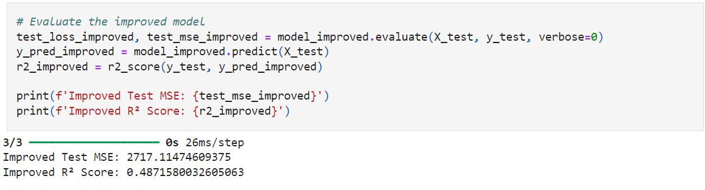

# 

# 

# **Explanation of Code Improvements**

Architecture Changes: Added more layers and neurons in the improved model to potentially capture more complex patterns. Performance Comparison: Compare the original and improved model's performance to determine if the changes led to better results.